SYSTEM ARCHITECTURE DOCUMENT
Keyword Classification
& Highlighting Pipeline
An image-first OCR pipeline that renders PDFs and images, corrects orientation, extracts text, classifies keyword matches, highlights them visually, and produces structured Excel and JSON reports.
DOCUMENT TYPE
Architecture Overview
CORE STACK
Python · PyMuPDF · OpenCV
SCOPE
Pipeline, Interfaces & Extensibility

1 Goals
This document describes the high-level architecture, component responsibilities, data flow, and extension points for the Keyword Classification & Highlighting pipeline.
- Reliable, image-first OCR pipeline for PDFs and images
- Clear separation of concerns: OCR, classification, highlighting, reporting
- Testable units and well-defined integration points
- Easy to extend with new OCR engines, reporters, or classifiers
2 Components
Each stage of the pipeline is implemented as a focused, swappable module with a clearly defined contract.
classify_and_highlight.py — CLI / Orchestrator
Entry point for the pipeline. Renders PDF pages to images, orchestrates orientation correction, OCR, classification, highlighting, and reporting.
Responsibilities: file discovery, rendering, per-page orchestration, final report assembly.

OCR Layer
Primary engine: PaddleOCR (fast, layout-aware). Secondary: Tesseract for OSD (orientation).
Functions: run_ocr_on_images, orientation helpers, and native-text extraction via PyMuPDF.

keyword_classifier.py
Loads keywords, performs exact / fuzzy / phrase matching, and groups matches for reporting.
Exposes: classify_ocr_results, load_keywords, and grouping helpers.

image_highlighter.py
Draws highlighted bounding boxes on images.
Strategy: prefers OpenCV; falls back to Pillow.

Reporters
Three modules handle output generation, each with a single, focused responsibility.
excel_reporter.py — styled Excel output (openpyxl)
json_reporter.py — structured JSON per document
generate_summary_excel.py — consolidates multiple JSONs into a summary workbook
ui_app.py — Optional UI
Tkinter GUI that wraps the CLI pipeline for interactive use.
3 Data Flow
The pipeline processes each document through eight sequential stages, looping per page until every page has been rendered, classified, and reported on.
1 | Input Discovery  CLI or UI produces a list of PDFs and images to process.
2 | PDF Rendering  For each PDF page: render to image and save as PNG.
3 | Orientation Correction  Tesseract OSD → PaddleOCR vote → Hough line hint, applied in cascade.
4 | OCR Extraction  PaddleOCR produces line/word tokens with bounding boxes.
5 | Keyword Matching  keyword_classifier matches tokens and generates match objects.
6 | Highlighting  image_highlighter annotates images for each match found.
7 | PDF Assembly  Annotated images are stitched into a single output PDF.
8 | Report Generation  Excel and JSON reports are saved with full match metadata.

Process Flow Diagram
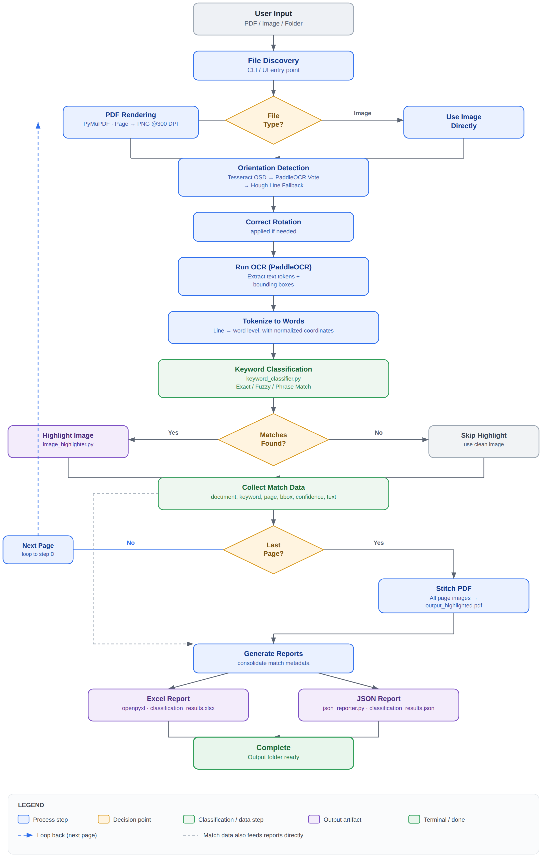
End-to-end pipeline flow, including the per-page rendering loop and parallel report generation.

4 Pipeline Steps Explained

STAGE | WHAT HAPPENS
Input Discovery | Find PDFs/images from CLI or UI
PDF Rendering | Convert each PDF page to PNG (300 DPI default)
Orientation Detection | Correct rotated pages (Tesseract → PaddleOCR → Hough fallback)
OCR Processing | PaddleOCR extracts text tokens with pixel & normalized coordinates
Keyword Matching | Classify each token: exact, fuzzy, partial, or phrase match
Highlighting | Draw colored bounding boxes on matched keywords (OpenCV or Pillow)
PDF Assembly | Stitch highlighted (or clean) images into the final output PDF
Report Generation | Create Excel and JSON summaries with match metadata
Output | Save to output folder — highlighted PDFs, Excel, JSON

Short-form summary
CLI/UI → Orchestrator → [Renderer → Orientation → OCR] → Classifier → {Highlighter, Reporters}

5 Component Interaction
The orchestrator drives a linear pipeline through rendering, orientation, and OCR, then fans out classification results to the highlighter and both reporters in parallel.
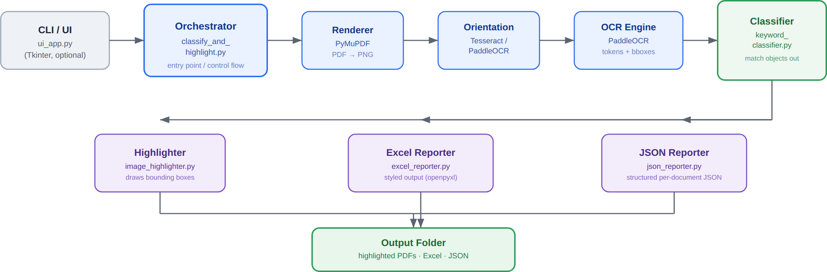
Component-level call graph, showing the orchestrator's central role and the parallel fan-out from the classifier.

6 Interfaces & Contracts
A single flat match object schema is shared across the classifier, highlighter, and both reporters — this is the contract that keeps the modules independently swappable.
FIELD | DESCRIPTION
document | Source document identifier
source_image | Rendered page image the match was found on
page | Page number within the document
text | Full OCR token text
matched_text | The specific substring that matched a keyword
keyword | The keyword definition that triggered the match
classification | Match type — exact, fuzzy, partial, or phrase
confidence | OCR / match confidence score
x1, y1, x2, y2 | Pixel-space bounding box of the match
norm_x, norm_y, norm_w, norm_h | Optional normalized bounding box coordinates
7 Extensibility
Add a new OCR engine — implement a thin adapter that returns the same token format used by the existing engines.

Add a new reporter — consume the match list and implement a writer function (save_...).

Replace the highlight strategy — swap out the image_highlighter implementation entirely.

8 Operational Concerns
Dependencies
PaddleOCR | openpyxl | PyMuPDF (fitz) | pytesseract | Pillow | OpenCV | python-Levenshtein

RECOMMENDATIONS
Supply a requirements.txt and use a virtual environment. Move logging from print() calls to Python's logging module with configurable verbosity. For long-running tasks, consider batching pages and using a worker pool for OCR.

SECURITY & PRIVACY
Avoid uploading documents to external services — run OCR locally. Ensure temporary images are stored in a configurable temp folder and cleaned up when possible.

9 Recommended Improvements
Near-term enhancements that would harden the pipeline for production use.
CONFIGURATION
Add config file support (YAML) for engine selection, DPI, thresholds, and output options.

RESILIENCE
Add retry / backoff handling for transient OCR errors, with robust exception handling throughout the pipeline.

TESTING & CI
Add unit and integration tests, plus a CI pipeline (see TDD.md).

